Project ACS
Design Specification
Accelerated Content Store
Docbase Version 1.3
June 1, 2005
Alex Oscherov

Revision History

Docbase  Version | Revised  Date | Revised By | Revision  Description
1.0 | 04/20/05 | Alex Oscherov | Initial revision
1.1 | 04/28/05 | Alex Oscherov | Revision on the initial feedback
1.2 | 04/29/05 | Alex Oscherov | Added description for configuration module
1.3 | 06/01/05 | Alex Oscherov | Definition of ACS URL extended to support CACS

Reference Document

1. ACS Functional specification.

1.0 Overview
This document describes design and public interfaces for Accelerated Content Store (ACS). Proposed design decisions were made based on the analysis of the requirements described in the [1]. Reading [1] is a necessary prerequisite to understanding this document.
ACS provides mechanism for accelerated access to the content for remote and close clients using multiple communication protocols.

Major assumptions
Design of the ACS was based on the functional specification and following assumptions
- In the first release only HTTP/HTTPS protocol for communication with clients will be supported but made design decisions should allow adding support for other communication protocols without changes in the overall architecture.
- ACS should be able to serve clients with the files of the unlimited size
- ACS may not implement support for “Ranges” HTTP header in the first release but design should allow to add this feature later without major changes
- ACS should equally support GET and POST requests of the HTTP protocol
- Even so upload operations won’t be supported in the first release Communication module should be from the design standpoint ready for upload oprations.

Design description

ACS overall class diagrams
Diagram shown below descirbes high level ACS archtecture
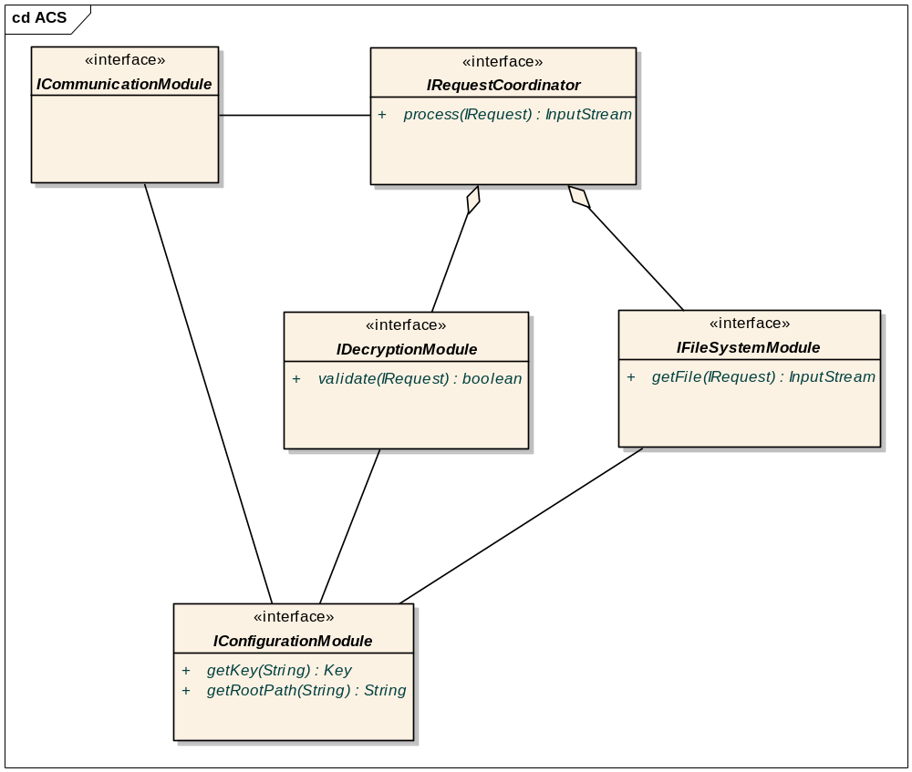
Figure 1 – ACS overall design diagram
As shown on the diagram ICommunicationModule first reads and parses input stream from the client. As a result it builds IRequest object. To process request farther ICommunicationModule instantiates IRequestCoordinator and calls method process on it passing IRequest as a parameter. This method essentially performs two steps
- Verifies validity of the request.
- If the first stage finishes successfully finds requested file and returns input stream to retrieve requested context.
ICommunicationModule takes this input stream surrounds it with all metadata necessary to support protocol (status, headers, and so on) and returns it to client.
Of the two stages mentioned earlier the first one gets performed by IDecryptionModule and second one gets performed by the IFileSystemModule. These two modules are singletons and IRequestCoordinator finds them when it gets instantiated. For configuration information all modules use IConfigurationModule.

Request class diagrams
IRequest that serves as an intermediary between all other components. It can be described by the following diagram
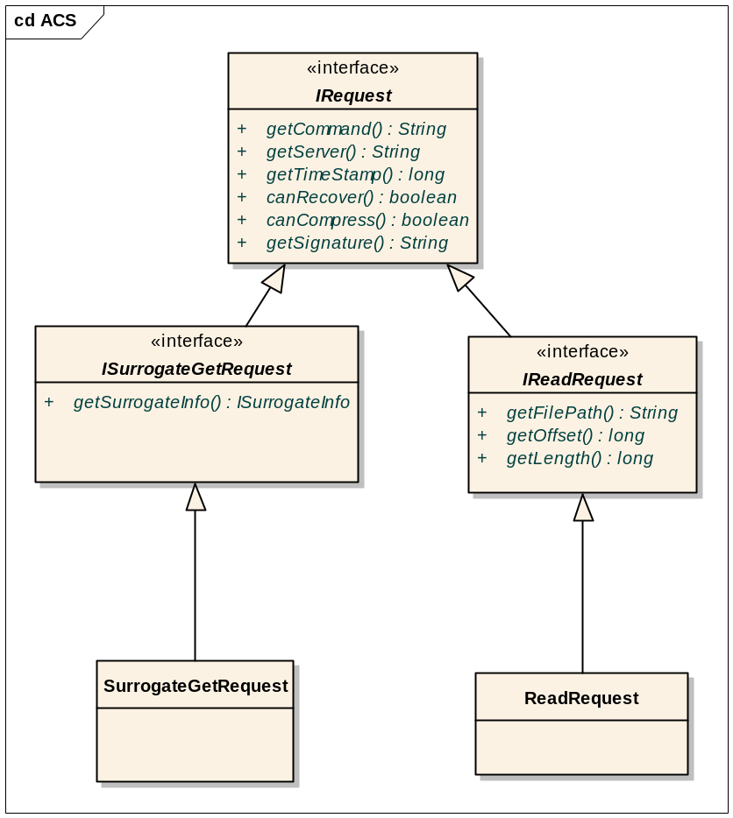
Figure 2 – Request design diagram
This design allows open ended extension of the operations supported by the ACS. Thus in the future it could support content uploading operations. The interfaces shown on the diagram are immutable. Classes that implement these interfaces will have all the methods necessary to set appropriate properties. If later it proves to be benefitial “set” methods could be added to the interfaces.

Communication module class diagrams
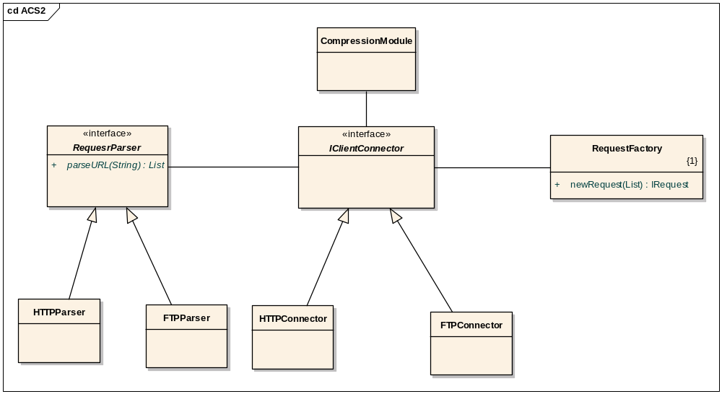
Figure 2 – Communication module design diagram
The central part of the communication module shown on the diagram above is IClientConnector interface. This interface could have several implementations depending on the type of clients the ACS is going serve on the diagram above it has two implementations as HTTP connector and FTP connector. IClientConnector interface has no methods it is a marker interface. For the HTTP case the implementation is a HTTPServlet class. Apparently in this case it runs in the servlet container. HTTPConnector should in general perform following activities
- Retrieve request
- Pass request to the URL parser. request parser will break request into list of pairs with parameter names and values.
- Pass this list of pairs to the RequestFactory that will build appropriate instance of IRequest and fill it with parameters
- Instantiate request coordinator and pass it request.
- Receive response from the request coordinator in the form of the Input Stream compress this stream if necessary add necessary headers and return to client.
- In the case when client supports recovery be ready to receive new recovery request from the client and restart transmitting from the position in the stream requested by the client.
- In the case when client requests “Ranges” several request coordirnators will be instantiated to return streams from the different parts of the file.

URL structure
For the clients using HTTP/HTTPS protocol the request they send to the ACS should be formed in a URL format. This URL consist of two major parts
- Base URL which is traditionally consist of
  - Protocol i.e. HTTP or HTTPS
  - Server name
  - Port number
  - Path which in our case of the servlet presents servlet mapping in the configuration file web.xml
- Parameter part that is specific for ACS functionality. This list of the parameters can be passed either as a part of URL or as a request body in the case when HTTP uses POST command. ACS will be able to process it either way. The parameters that can be present in the parameter list are enumerated below
  - Command - this parameter specifies the command that is sent to the ACS i.e. read or write. In the first release ACS supports only read command. The format for this parameter is “command=<command value>”. This parameter must be present.
  - Docbase – this parameter specifies unique Docbase identifier from which this URL is originated. The format for the parameter is “docbase= <identifier>. This parameter must be present
  - File path – this parameter specifies relative path to the file on the file system relative to the mapping of the root of the Docbase. The format for the parameter is “filepath = <filepath>”. This parameter is optional. But URL must contain either this parameter or group of four parameters described right below and necessary to perform “surrogate get” or “get”.This parameter should be URL encoded to guarantee its transmission over HTTP.
  - Document ID – this parameter specifies ID of the document in the Docbase. The format of the parameter is “document_id= <ID>”. This parameter is optional it shouldn’t be present if file path parameter is used and target server is ACS not CACS but it should be present with the group of other parameters – format, page numer and page modifier to support “surrogate get” and CACS
  - Format - this is another parameter in the group of the parameters necessary to support “surrogate get” and CACS. The format for this parameter is “format=<format>”.
  - Page Number – anoter parameter in the group of “surrogate get”/CACS support parameters. This format for it is – “pagenum=<Page Number>”.
  - Page Modifier – fourth in the group of the parameters that support “surrogate get” or CACS. The format for it – “pagemod = <modifier>”
  - Origination Time – this is the parameter that specifies the time when CS generated request. This time is present as a number of the milliseconds since January 1st 1970 GST. This parameter is presented as “timestamp=<longvalue>”. This parameter must be present.
  - Signature – this parameter provides digital signature for request authentication and protection from tampering. The format for this parameter is “signature=<signature>”. How this signature is formed will be described in the chapter desribing decryption module. This parameter must be present in the any request.
  - Compression – this parameter notifies ACS that client expects UCS style compression (see UCF Design Specification). The format for this parameter is “compression=true/false”. This parameter is optional. When this parameter is not present the assumed value is “false”.
  - Recovery – this parameter notifies ACS that communication was interrupted and it requires ACS to restore data transmission. This parameter is used with two other parameters: “Length” and “Offset”. The format for this parameter is “recovery=true/false”. This parameter is optional. When this parameter is not present the assumed value is “false”.
  - Offset – this parameter tells ACS what should be offset for the file downloaded to the client. The format for this parameter is “offset=<long number in bytes>”. This parameter is optional and default value for it is “0”
  - Length – this parameter specifies how many bytes should be downloaded from the ACS to client. The format for this parameter is “length=<long number of bytes>”. The default value for this parameter is “-1” which means all bytes till the end of the file. This parameter is optional.
  - Mime type = this parameter specifies the value that will be set for in the HTTP response for mime type header. The format for this parameter is “mime_type=<mime type>”. This parameter is optional.
  - Transient - this parameter specifies the transient parameter that ACS has to return as a response header to client. This parameter is optional and necessary only if client wants to pass transient parameters.
  - Transient delimiter – this parameter specifies delimeter between header name and header value that client requires to return with HTTP response from ACS. The format for this parameter is “transient_delimiter=<delimiting string for example ::>. In this case transient parameters will look like tr=header_name::header_value. This parameter is optional and should be present only if previous parameter “Transient” is also present.
  - For the CACS the should be additional parameters that include:
    - URL for the ACS that should be used when content is not found in the on the caching service. The format for this parameter is “acs_url=<base part of the ACS URL to access content>”
    - Content object ID – this parameter is used by the CACS in conjunction with four previously described parameters: Document ID, format, page number and page modifier to uniquely identify piece of content. This parameter has format “content_obj_id=<some_id>”

Here is presented example of URL passed to the ACS:
https://someserver:8443/servlet/main?command=read&docbase=dm_notes&filepath=path1/path2/path3/file.txt&timestamp=1114639011343&signature=00000000000&compression=true&mime_type=text&transient_delimiter=::&transient=header1::value1&transient=header2::value2
Another example present URL for CACS
https://someserver:8443/servlet/main?command=read&docbase=dm_notes&filepath=path1/path2/path3/file.txt&timestamp=1114639011343&signature=00000000000&compression=true&mime_type=text&transient_delimiter=::&transient=header1::value1&transient=header2::value2&document_id=0x00800000&format=some_format&pagenum=1&pagemod=some_mod&content_obj_id=0x0000000&acs_url=%3Dblalblabla

File system module class diagrams
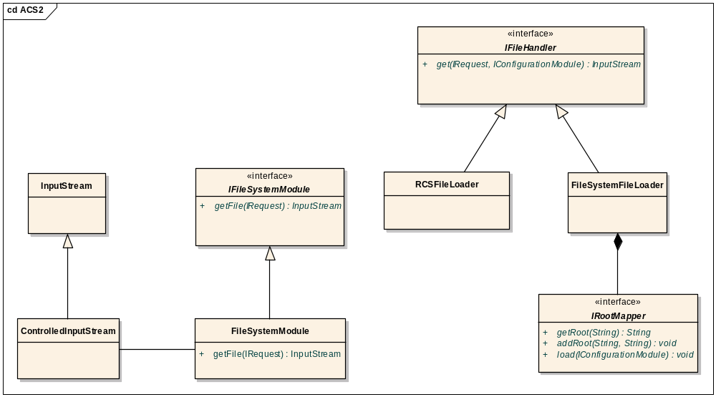
File System module main responsibility is to retrieve requested file from the file system and return it as an InputStream. IRootMapper provides mechanism to map Docbase name into root path depending on the mapping between Docbases and filestores. This mapping is defined in the ACS configuration object and at the system startup configuration module populates IRootMapper using either method load or addRoot. When IFileSystemModule returns InputStream it first translates relative path kept into IRequest into format matching operating system on which ACS is running. I.e in the case when CS was Windows and ACS was UNIX it convert from Windows into UNIX. It then adds root path and creates ControlledInputStream. This input stream provides protection so that client code reads only specidfied number of bytes from the defined offset. Also this stream serves as a mechanism to implement recovery (?). In the case when ACS is unable to retrieve content from the local filestore due to the fact that content was not yet replicated or this ACS just doesn’t support this type of filestore (encrypted or compressed) then FileSystemModule redirects the call to the RCSFileLoader so that it can get content input stream using DFC. DFC has method getFile which will copy file on the ACS local file system. The responsibility to clean up this file will lie on Controlled Input Stream. Because retrieving information through RCS requires some privileges this class uses IConfigurationModule to retrieve this information from it.

Decryption module class diagrams
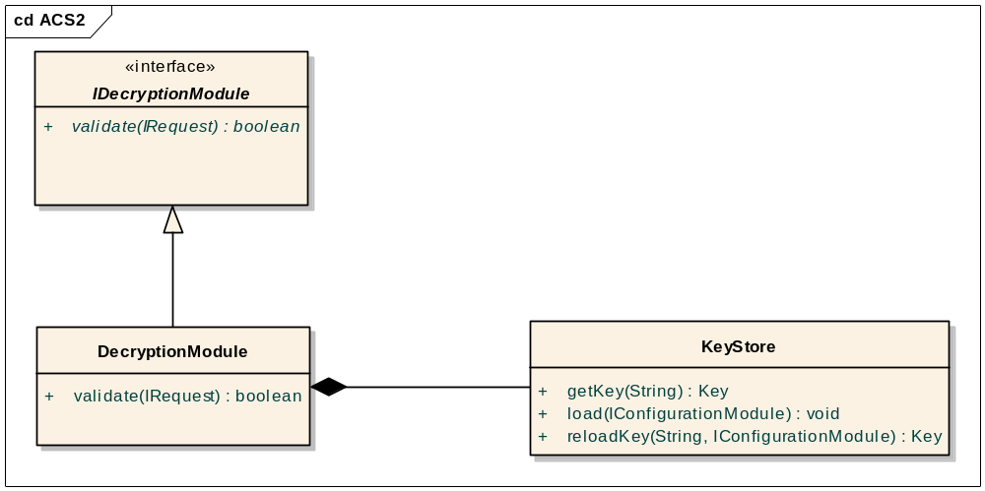
This module provides verification for the received request based digital signature mechanism. The module is designed in a way that it can use symmetric (secret) or asymmetric (public/private) key without any design change. Key store provides caching mechanism for keeping keys for all CS that use this ACS. During initial configuration Key Store using IConfigurationModule retrieves keys from all servers using server method “export” to get ACS encryption key that is specialized key for ACS URL encryption/decryption. To access this method ACS should have special credentials (login name and password or persistent login ticket) for this server. Management of this information provided by IConfigurationModule. Because server can change key during ACS running Key Store has special method reload key. I.e. if decryption fails it should try to load the key from the CS anew.

Configuration module class diagrams
Configuration module is a utility singleton module that provides running environment for all other modules
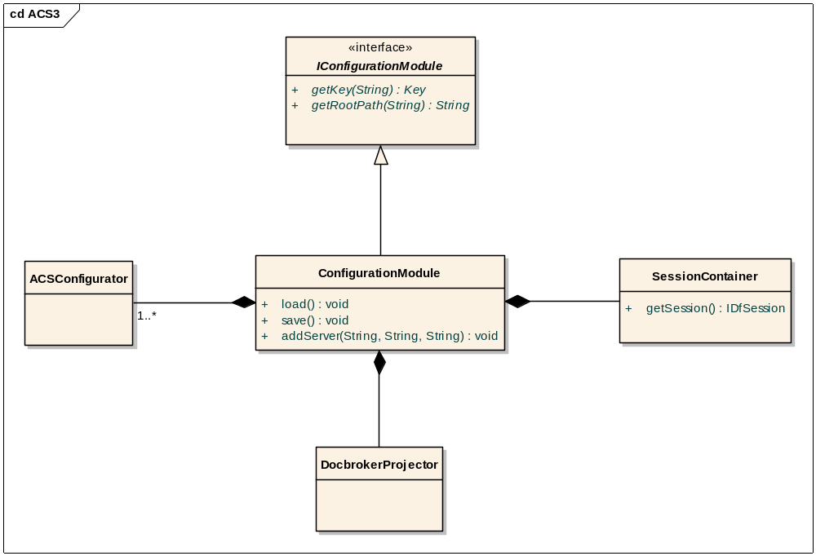
Configuration module manages list of all servers supported by the ACS this management consist of two parts
- Managing list of the supported servers. This list contains names of all Docbases and administrative login names and password for them. Due to the sensitive nature of this information Configuration module keeps this information in the file in the encrypted form (How to encrypt it?). Configuration module has all interfaces necessary to manage this file.
- Managing ACS configuration objects from all Docbases. For that purpose ConfigurationModule contains map of objects of the type ACSConfigurator that contain all information from the ACS configuration object in the Docbase.
Docbroker Projector as a part of the Configuration module projects ACS to the Docbrokers so that DFC could check its status. Docbroker projector gets from the ACSConfigurators list of the docbrokers where to project and also frequesncy with wich to project. To provide regular projection Docbroker projector extends TimerTask from the JDK.
Configuration module also provides DFC session support for all servers. For that configuration module keeps map of session managers for all Docbases. And on any request returns new IDfSession.
Also Configuration service serves as a wrapper to call method “export” to get access for symmetric key for every docbase.

Public API
This product is a standalone application and as such doesn’t have public API

